**LAB 4**

**Task # 01: Create vertical linear layout also apply weights.**

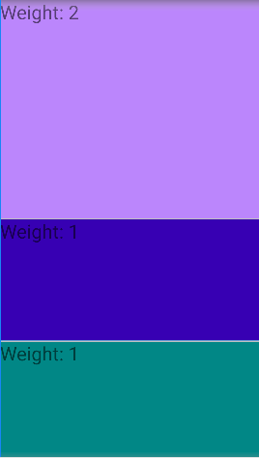**XML CODE:***<?***xml version="1.0" encoding="utf-8"***?>*<**LinearLayout xmlns:android="http://schemas.android.com/apk/res/android"  
 xmlns:app="http://schemas.android.com/apk/res-auto" OUTPUT:  
 xmlns:tools="http://schemas.android.com/tools"  
 android:layout_width="match_parent"  
 android:layout_height="match_parent"  
 tools:context=".MainActivity"  
 android:orientation="vertical"**>  
 <**TextView  
 android:id="@+id/login"  
 android:layout_width="match_parent"  
 android:layout_height="wrap_content"  
 android:text="Weight: 2"  
 android:layout_weight="2"  
 android:background="@color/purple_200"  
 android:textSize="30sp"**/>  
 <**TextView  
 android:layout_width="match_parent"  
 android:layout_height="wrap_content"  
 android:text="Weight: 1"  
 android:layout_weight="1"  
 android:background="@color/design_default_color_primary_dark"  
 android:textSize="30sp"**/>  
 <**TextView  
 android:layout_width="match_parent"  
 android:layout_height="wrap_content"  
 android:background="@color/teal_700"  
 android:text="Weight: 1"  
 android:layout_weight="1"  
 android:textSize="30sp"**/>  
</**LinearLayout**>

**Task # 02: Implement the design given below by using LinearLayout.**

**XML CODE:***<?***xml version="1.0" encoding="utf-8"***?>*<**LinearLayout xmlns:android="http://schemas.android.com/apk/res/android"  
 xmlns:app="http://schemas.android.com/apk/res-auto"  
 xmlns:tools="http://schemas.android.com/tools"  
 android:layout_width="match_parent"  
 android:layout_height="match_parent"  
 tools:context=".MainActivity"  
 android:orientation="vertical"**>  
 <**LinearLayout  
 android:layout_width="match_parent"  
 android:layout_height="wrap_content"  
 android:orientation="horizontal"  
 android:layout_weight="2"**>  
 <**EditText  
 android:id="@+id/editTextTextPersonName"  
 android:layout_width="wrap_content"  
 android:layout_height="match_parent"  
 android:ems="10"  
 android:layout_weight="3"  
 android:inputType="text"  
 android:text="0"  
 android:textSize="20sp"  
 android:gravity="right"**/>  
 <**Button  
 android:layout_width="wrap_content"  
 android:layout_height="match_parent"  
 android:text="C"  
 android:layout_weight="1"  
 android:textSize="20sp"**/>  
 </**LinearLayout**>  
 <**LinearLayout  
 android:layout_width="match_parent"  
 android:layout_height="wrap_content"  
 android:orientation="horizontal"  
 android:layout_weight="1"**>  
 <**Button  
 android:layout_width="wrap_content"  
 android:layout_height="match_parent"  
 android:text="7"  
 android:textSize="20sp"  
 android:layout_weight="1"**/>  
 <**Button  
 android:layout_width="wrap_content"  
 android:layout_height="match_parent"  
 android:text="8"  
 android:textSize="20sp"  
 android:layout_weight="1"**/>  
 <**Button  
 android:layout_width="wrap_content"  
 android:layout_height="match_parent"  
 android:text="9"  
 android:textSize="20sp"  
 android:layout_weight="1"**/>  
 <**Button  
 android:layout_width="wrap_content"  
 android:layout_height="match_parent"  
 android:text="+"  
 android:textSize="20sp"  
 android:layout_weight="1"**/>  
 </**LinearLayout**>  
 <**LinearLayout  
 android:layout_width="match_parent"  
 android:layout_height="wrap_content"  
 android:orientation="horizontal"  
 android:layout_weight="1"**>  
 <**Button  
 android:layout_width="wrap_content"  
 android:layout_height="match_parent"  
 android:text="4"  
 android:textSize="20sp"  
 android:layout_weight="1"**/>  
 <**Button  
 android:layout_width="wrap_content"  
 android:layout_height="match_parent"  
 android:text="5"  
 android:textSize="20sp"  
 android:layout_weight="1"**/>  
 <**Button  
 android:layout_width="wrap_content"  
 android:layout_height="match_parent"  
 android:text="6"  
 android:textSize="20sp"  
 android:layout_weight="1"**/>  
 <**Button  
 android:layout_width="wrap_content"  
 android:layout_height="match_parent"  
 android:text="-"  
 android:textSize="20sp"  
 android:layout_weight="1"**/>  
 </**LinearLayout**>  
 <**LinearLayout  
 android:layout_width="match_parent"  
 android:layout_height="wrap_content"  
 android:orientation="horizontal"  
 android:layout_weight="1"**>  
 <**Button  
 android:layout_width="wrap_content"  
 android:layout_height="match_parent"  
 android:text="1"  
 android:textSize="20sp"  
 android:layout_weight="1"**/>  
 <**Button  
 android:layout_width="wrap_content"  
 android:layout_height="match_parent"  
 android:text="2"  
 android:textSize="20sp"  
 android:layout_weight="1"**/>  
 <**Button  
 android:layout_width="wrap_content"  
 android:layout_height="match_parent"  
 android:text="3"  
 android:textSize="20sp"  
 android:layout_weight="1"**/>  
 <**Button  
 android:layout_width="wrap_content"  
 android:layout_height="match_parent"  
 android:text="*"  
 android:textSize="20sp"  
 android:layout_weight="1"**/>  
 </**LinearLayout**>  
 <**LinearLayout  
 android:layout_width="match_parent"  
 android:layout_height="wrap_content"  
 android:orientation="horizontal"  
 android:layout_weight="1"**>  
 <**Button  
 android:layout_width="wrap_content"  
 android:layout_height="match_parent"  
 android:text="."  
 android:textSize="20sp"  
 android:layout_weight="1"**/>  
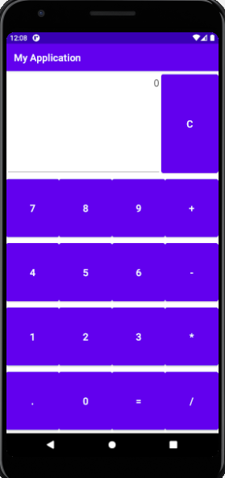 <**Button  
 android:layout_width="wrap_content"  
 android:layout_height="match_parent"  
 android:text="0"  
 android:textSize="20sp"  
 android:layout_weight="1"**/>  
 <**Button  
 android:layout_width="wrap_content"  
 android:layout_height="match_parent"  
 android:text="="  
 android:textSize="20sp"  
 android:layout_weight="1"**/>  
 <**Button  
 android:layout_width="wrap_content"  
 android:layout_height="match_parent"  
 android:text="/"  
 android:textSize="20sp"  
 android:layout_weight="1"**/>  
 </**LinearLayout**>  
</**LinearLayout**>

**OUTPUT:**